# **Introduction**

# The Summit of Heads of State and Government of the African Union made a decision to establish the Pan African University (PAU) in 2010, and the plan to implement PAU was based on utilizing existing universities of eminence and quality on the continent to create a network of institutions of excellence that will foster world class research and academic mobility. PAU operates under the direction of the African Union Commission (AUC) Department of Human Resources, Science and Technology, as one University managed by a single Rectorate and supervised by a Council.

# PAU continues to deliver on its mandate of enrolling and graduating students, through teaching and research at its four operational Institutes in Algeria, Cameroon, Kenya and Nigeria. 2016 has been a busy year for the PAU, with the Rectorate and various Institutes embarking on series of activities pertaining to University governance, planning and coordination, curriculum development, as well as student admission and graduation.

**Negotiations on the Relocation of the PAU Rectorate to Cameroon**

Following the decision to designate of the Republic of Cameroon as Host of the Pan African University by the AU Assembly of Heads of State and Government in January 2015, the Commission and Cameroonian government officials have been working closely to implement the decision. Following up to official correspondence and consultation between the two sides, the Commission in March 2016 dispatched a four-member delegation led by the President of the PAU Council, Professor Tolly S. Mbwette, to Yaounde, to meet officials of the Government of Cameroon and assess the state of readiness of the facilities and amenities required for the relocation of the PAU Rectorate.

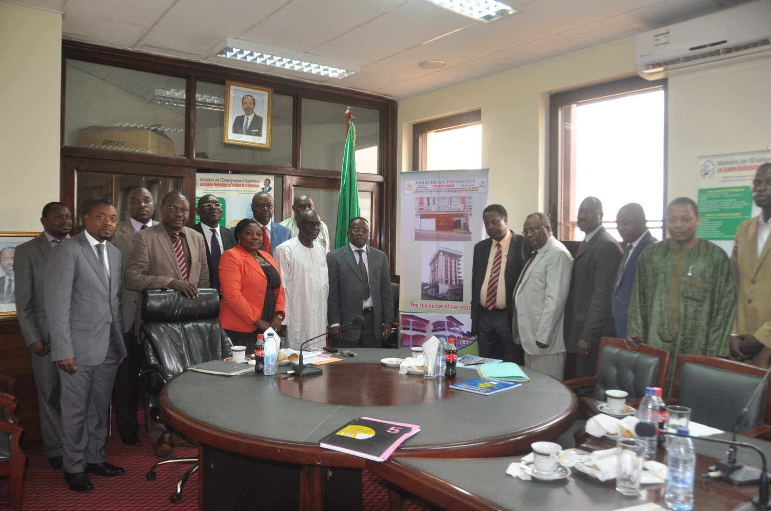

During the mission, the delegation held meetings with the Cameroonian Ministers of Higher Education and External Relations. Having expressed gratitude for the Cameroonian Government’s unparalleled collaboration and cooperation with the African Union Commission in finalizing the implementation of the PAU project, the delegation stressed the importance of finalizing and signing the hosting agreement as a pre-condition for the physical relocation of the PAU Rectorate to Yaounde.

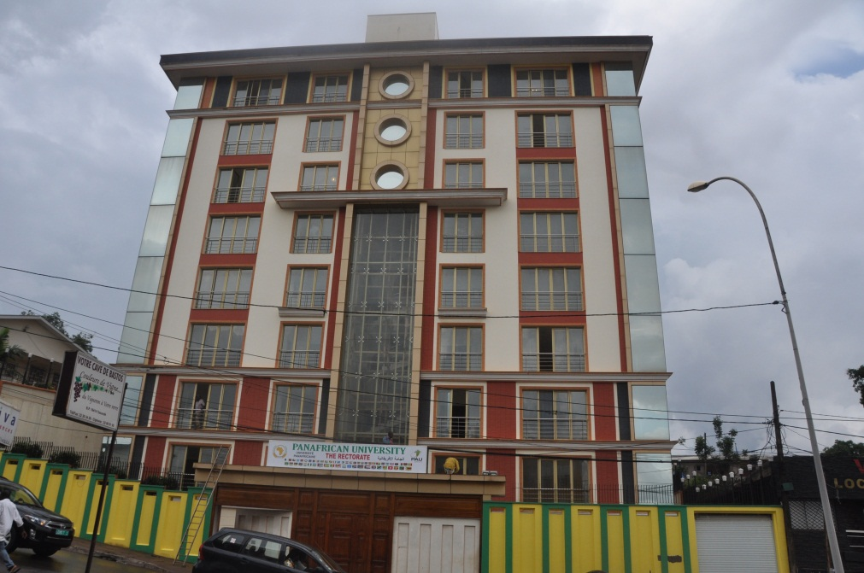

The delegation was informed that on the part of the Government of Cameroon, the only outstanding issue in the hosting agreement related to the question of privileges and immunities for Cameroonian nationals who may be employed by the PAU Rectorate. The delegation visited and inspected a nine-story building located in the Bastos neighborhood of Yaounde, placed at the disposal of the Pan African University by the Government of Cameroon to serve as the temporary location of the Rectorate, pending the construction of a permanent Rectorate building. The delegation also visited and inspected the proposed residence of the Rector. Both buildings were being furnished, and according to officilas of the Ministry of Higher Education, a contractor had been engaged to install the necessary ICT infrastructure including video conferencing facilities, networking and communications infrastructure in the Rectorate building and at the residence of the Rector.

**First PAUGHSS Graduation**

The first batch of 51 students of the Pan African University Institute for Governance, Humanities and Social Sciences (PAUGHSS) graduated on 30 March 2016, with Master of Arts (MA) degrees at a ceremony held at the *Palais des Congrès* in Yaoundé, Cameroon. After three years of postgraduate studies research and internships in their respective disciplines, 41 graduating students received MA degrees in governance and regional integration jointly conferred by the Pan African University (PAU) and the University of Yaoundé II, whilst the remaining 10 students received MA degrees in Conference Interpreting and Translation, jointly conferred by the PAU and the University of Buea. The graduating students, who come from 16 different African Union Member States, constitute the third batch of students graduating from the PAU, an African Union educational flagship programme seeking to expand the frontiers of higher education, research and innovation in the continent.

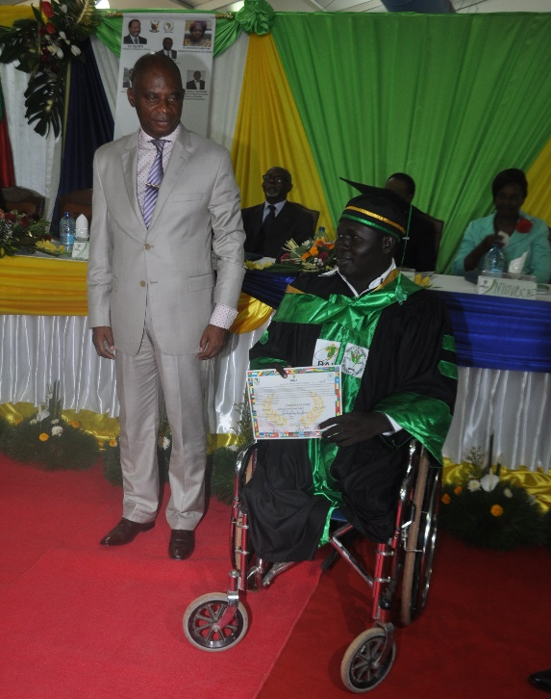Top officials of the Government of Cameroon, the diplomatic and academic community in Yaoundé and Buea, as well as development partners, attended the graduation ceremony. The African Union Commission was represented by: Prof. Tolly S. A. Mbwette, President of the PAU Council; Dr. Jean Gérard Mezui M’ella, Director of the AU Inter-African Phytosanitary Council Office in Yaoundé; Dr. Mahama Ouedoraogo, Ag. Director, HRST; Prof. Belay Kassa, Interim Deputy Rector, PAU; and Dr. Yaw Nyampong, PAU Senior Legal Officer. It marked a significant milestone in the drive towards actualizing the foundational ideals of the PAU and generated enormous regional and international focus.

Speaking at the ceremony, Prof. Tolly S. A. Mbwette, President of the PAU Council, expressed gratitude on behalf of the African Union to the Government of Cameroon and the two host institutions of PAUGHSS, the University of Yaoundé II (Soa) and the University of Buea as well as other Cameroonian and African universities, for their unparalleled collaboration and cooperation with the African Union Commission in the implementation of the PAU project. He placed particular emphasis on the Government’s continuing commitment and its numerous efforts in preparation to receive the Rectorate of the PAU, which, by virtue of a 2015 Decision of the Assembly of Heads of State and Government of the AU, will be permanently headquartered in Yaoundé.

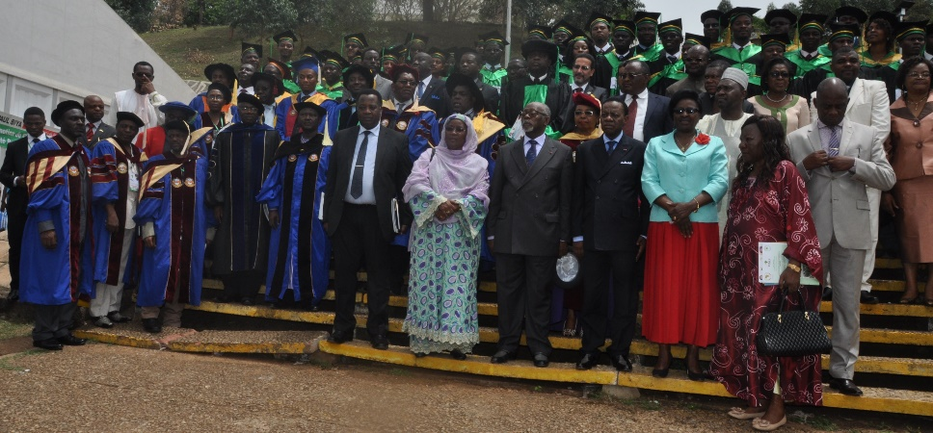In his keynote address, Prof. Jacques Fame Ndongo, the Minister of Higher Education of the Republic of Cameroon and Chancellor of Academic Orders, charged the graduating students to go forth as ambassadors of Africa and serve as agents of change, using the knowledge and training they have obtained. He thanked the African Union for the trust reposed in the Cameroonian higher education system as evidenced by the selection of Cameroon to host PAUGHSS and the PAU Rectorate. Professor Ndongo underlined the unflinching commitment of the Government of Cameroon to sharing its legacy in higher education with other Member States by supporting continental initiatives such as the Pan African University.

Hosted by the University of Yaoundé II and the University of Buea, PAUGHSS offers MA programmes in governance and regional integration, conference interpretation and translation, with plans to introduce many more programmes in the MA as well as PhD streams in the short and medium term.

**PAU Curriculum Validation Workshop**

The Department of HRST and PAU convened a curriculum validation workshop for the PAU Institute for Governance, Humanities and Social Sciences (PAUGHSS), on the 8th of April 2016, at the Commission Headquarters in Addis Ababa, Ethiopia. The workshop was attended by staff of the Commission and the PAU Rectorate, PAU Institute Directors, Program Coordinators at PAUGHSS, African experts in Governance, Humanities and Social Sciences, and African Union Youth Volunteers. It was the culmination of efforts to review existing curricula for the various Masters programs being administered at PAUGHSS in Yaounde, Cameroon, and develop curricula for newly introduced PhD programs of the Institute.

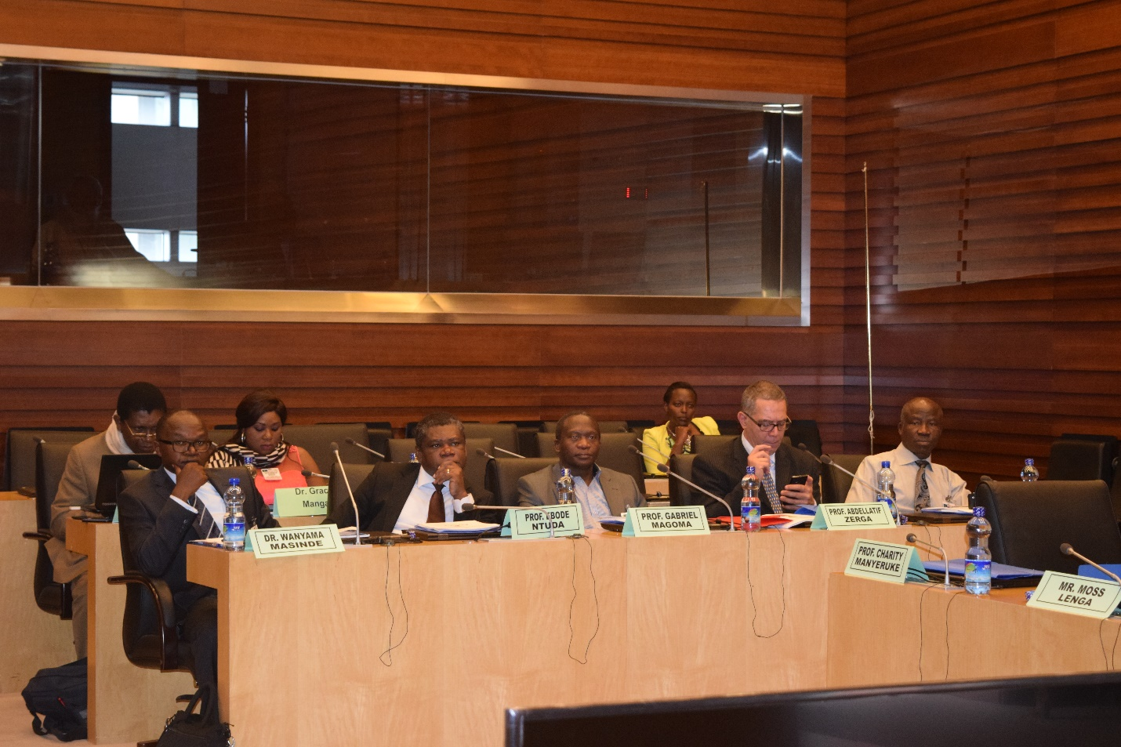The validation workshop, which was preceded by a two-day pre-validation session, covered Masters and PhD programs in Governance and Regional Integration, Translation and Interpreting, as well as Gender and Human Rights, and History of Africa – both mandatory courses for all PAU students. The curriculum exercise was underpinned by the need to align PAU curricular with the highest standards of global practice and ensure congruence between learning outcomes of Masters and successive PhD courses. It was also inspired by the drive to infuse PAU curricula with the African perspective and embed the University’s programs with relevant courses that reflect the continent’s objective realities.

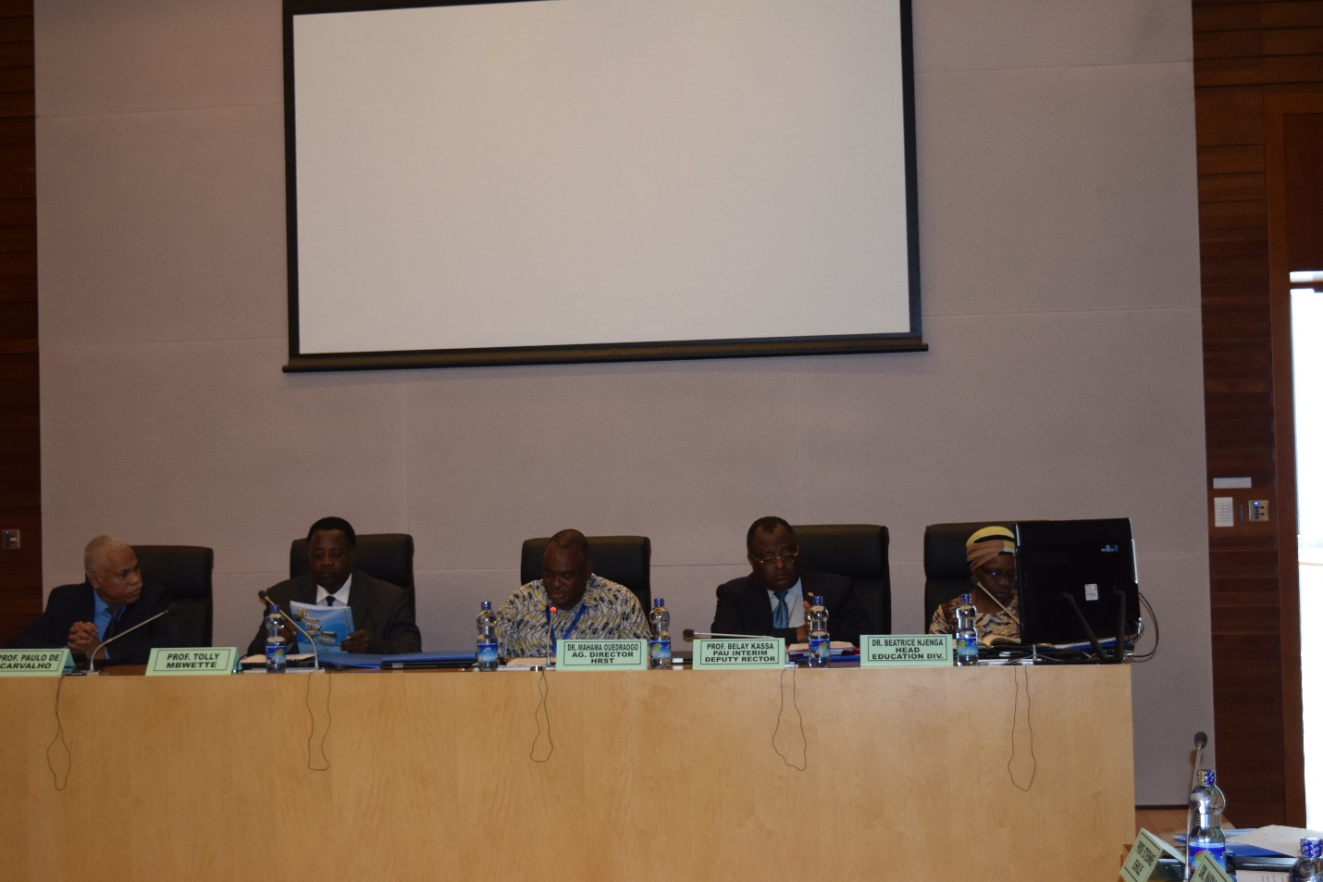

Lead experts of the various teams assigned to work on program and course curricula made presentations on the scope and details of their work, as well as the input generated from the pre-validation sessions. The team presentations covered Masters and PhD curricula in Governance and Regional Integration, Translation, Interpreting, as well as curricula for the PAU mandatory courses of Gender and Human Rights, and History of Africa. The presentations generally touched on introductory and background notes on the programs/courses, their aims and objectives, as well as expected learning outcomes. The experts also outlined course contents and structure, duration, admission requirements, credit components, research portfolio and learning references and resources for each of the programs and courses.

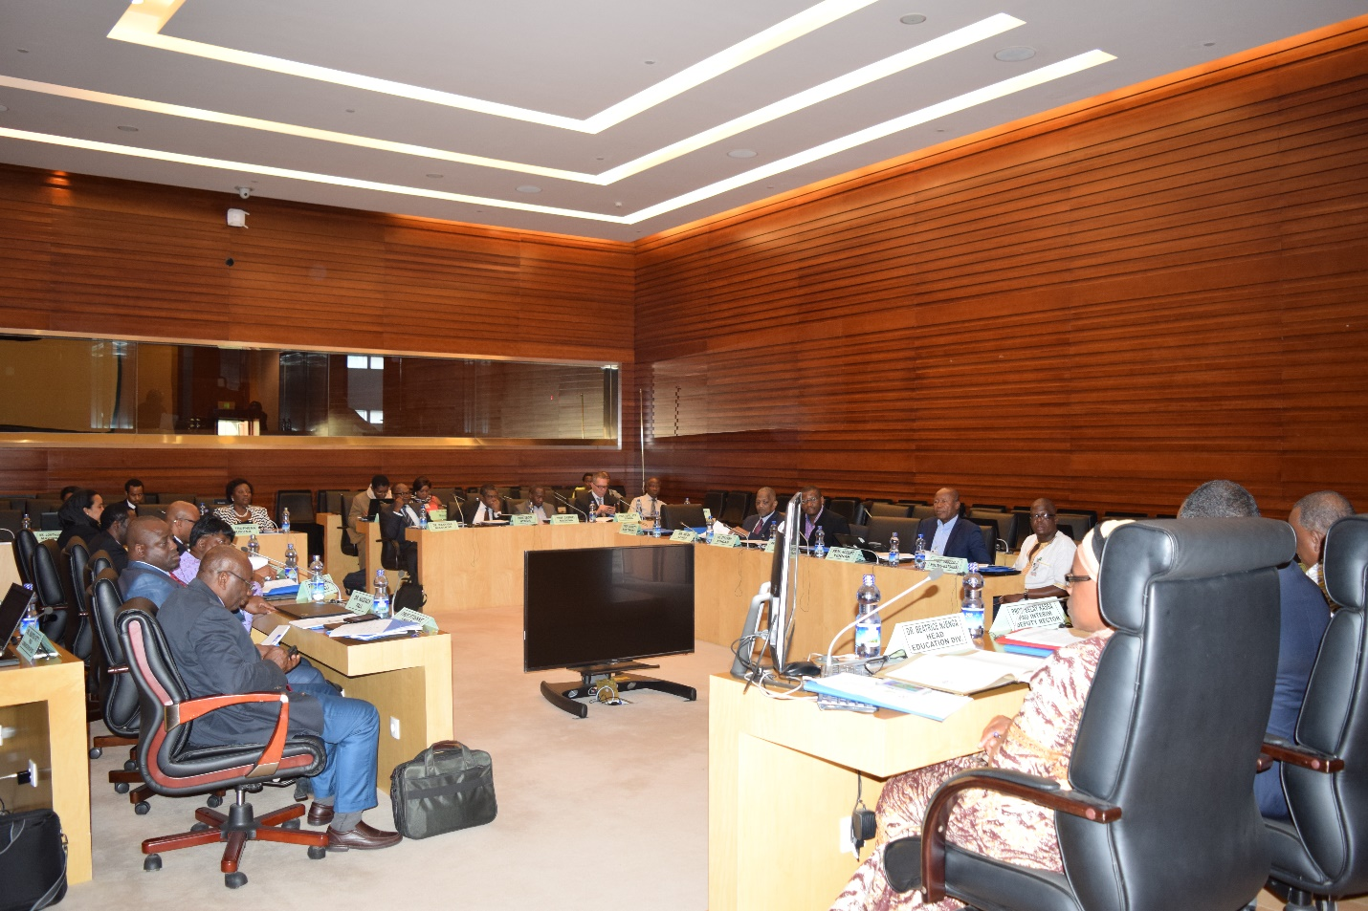Key highlights of the presentations included the elaboration by the expert group for **Gender and Human Rights** of the background to AU Gender and Human Rights instruments and the engagement of the learners with these instruments. The team took cognizance of the need to raise student awareness about Gender and Human Rights as cross-cutting issues, and to capture the conceptual foundations, African traditional systems and mechanisms of human rights in the Gender and Human Rights module. It also saw the need to expound the full spectrum of rights under Gender.

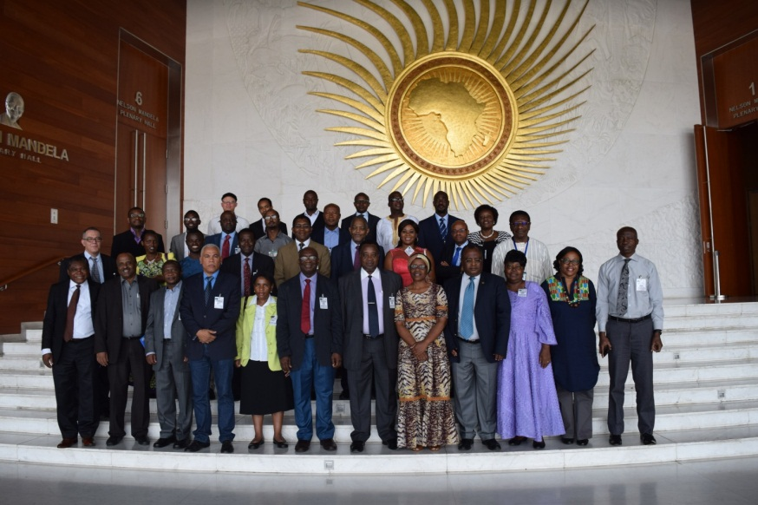The expert group for the **History of Africa** clarified the ambiguity of the thematic titles and organized the canonical texts more systematically, in order of theme. The group repositioned Pan-Africanism as a core component of the course to project its relevance and uniqueness as an African Union agenda. The **Governance and Regional Integration** expert group expanded the practical and theoretical dimensions of the programs, both of which needed ample consideration. The team added research methodology as a key course in the GRI curriculum.

At the end of workshop proceedings, participants agreed on a broader context, that in order to create a more convenient academic, research and curricula framework, PAU should seek to accomplish the following:

* Adopt a standardized format for curriculum design;
* Prepare a handbook to guide postgraduate study, taking into account existing guidelines of the host universities ;
* Engage the RECs as pillars of the African Union, in admitting PAU students on internships ;
* Exploit the possibility of creating internship opportunities for PAU students within the AUC and at other AU institutions.

**Planning and Coordination Meetings of PAU Institute Directors and Rectorate Staff**

Officials of the PAU Rectorate and PAU institute Directors met on the 7th of April 2016 at the AUC Headquarters in Addis Ababa, as part of the regular consultative planning process to discuss academic, administrative and policy issues bordering on the operations of the Institutes as well as the Rectorate. The meeting agenda centered on key matters that form part of discussions during the previous planning meeting. These include periodic updates by the Institutes, student admission for the 2016/2017 academic year, and the student research fund among other issues.

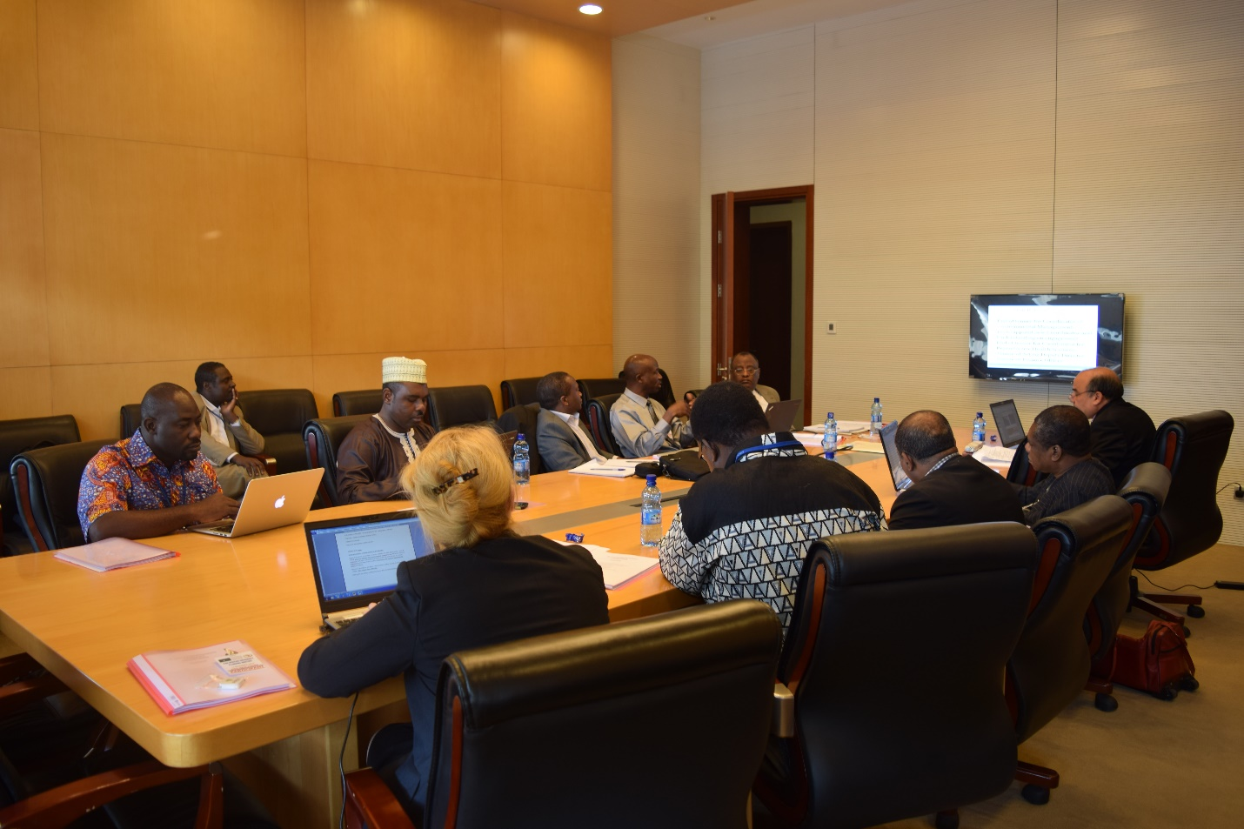

The PAU Rectorate and Institute Directors convened another planning and coordination meeting from the 10 to 11 August 2016 at the PAU Institute for Basic Sciences, Technology and Innovation (PAULESI) in Nairobi, Kenya. The meeting considered the periodic reports from Institute Directors, after an update from the Interim Deputy Rector on the recruitment of long term academic staff. The meeting also discussed issues related to research funding, the 2016/2017 academic calendar, as well as PAU management and finance related issues.

**Negotiations on the Establishment and Operationalization of the PAU Space Sciences Institute**

Under the current Pan African University framework, the University constitutes five Institutes distributed across Africa’s five regions. Four of the PAU’s Institutes in the Western, Eastern, Central and Northern regions are already operational. South Africa was nominated by SADC to host the PAU Space Sciences Institute (PAUSS) on behalf of the Southern Africa region.

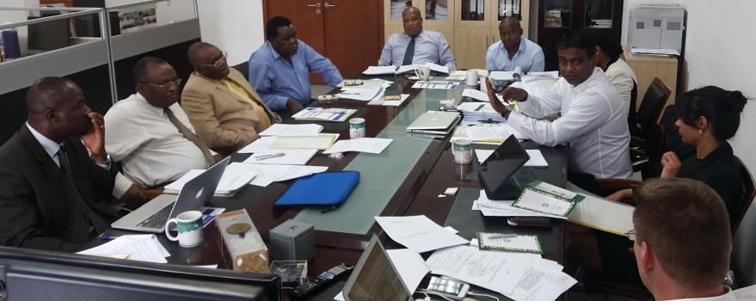Following South African selection by SADC to host the PAU Space Sciences Institute, series of meetings have been held between the AU Commission and South African authorities, including a mission to Johannesburg in March 2015, led by the Commissioner for Human Resources, Science and Technology, H.E Dr. Martial De-Paul Ikounga, and a

joint technical meeting at the AU Commission in Addis Ababa, on 26 and 27 October 2015, between officials of the Department of Human Resources, Science and Technology and a delegation from South Africa. The two parties have also been consulting and communicating on the technical modalities for the implementation of PAUSS.

On July 1, 2016 a three-person AUC delegation was on a mission in South Africa to discuss on the operationalization of the PAU Institute for Space Sciences. The delegation had very useful and productive meetings with the Technical Team members commissioned to prepare the ground work for the operationalization of the PAU Institute. The two parties discussed in detail the outcome of the internal audit made by the South African Government and agreed to speed up the process required for the operationalization of the Pan African University Institute for Space Sciences.

The South African Government dispatched a Team of Experts to PAUSTI (Nairobi) and PAUWES (Tlemcen) for experience sharing visits to learn firsthand the way the PAU Institutes are run and managed. During a technical meeting between South Africa and the AUC on the draft Host Agreement for the PAUSS held on 25 August 2016 at the AUC Headquarters in Addis Ababa, the team members underscored how the visits offered the opportunity for them to better understand and appreciate the PAU governance structure, vis-à-vis the staffing needs and requirements of the Institutes. A number of recommendations emanated from the visit to PAU Institutes, underpinned by observations on PAU student selection, funding, Institute management and partnerships among other issues. South Africa has identified Cape Peninsula University of Technology (CPUT) as the central and main Host for the PAU Space Sciences Institute, with seven other participating Universities.

At the end of the meeting, both parties agreed to take note of and consider the suggestions and issues raised during the negotiations, and to continue exchanging notes on proposed amendments to the drafts for further clarity and consensus.

**Student Selection for the 2016-2017 Academic Year**

The Pan African University Rectorate has been taking the necessary steps to admit new students to the four thematic institutes of the Pan African University. The call for scholarship applications for the 2016/2017 academic year was posted on 3 February 2016 and closed on 1 April 2016. About 5,432 applications (3670 for M.Sc. and 1762 for PhD) were received.

The Planning and Coordination meeting held in Nairobi on 10 and 11 August recommended the admission of 414 (107 PhD and 307 MA/MSc.) new students for the 2016/2017 academic year. This breaks down to 100 (30 PhD and 70 MA) students at PAUGHSS, 106 (31 PhD and 75 MSc.) students at PAULESI, 123 (46 PhD and 77 MSc.) students at PAUSTI, and 85 MSc. students at PAUWES. The detailed breakdown of the selected students is provided in the tables below.

**Table 1: Newly Selected PhD and Masters’ Students for Admission to PAUGHSS in 2016/2017 Academic Year**

|  |  |  |  |
| --- | --- | --- | --- |
| Area of Specialization | Female | Male | Total |
| PhD in Governance and Regional Integration | 7 | 23 | 30 |
| MA in Governance and Regional Integration | 21 | 29 | 50 |
| MA (Translation) | 3 | 4 | 7 |
| MA (Interpretation) | 7 | 6 | 13 |
| Total | **38** | **62** | **100** |

**Table 2: Newly Selected PhD Students for Admission to PAULESI in 2016/2017 Academic Year**

|  |  |  |  |
| --- | --- | --- | --- |
| Area of Specialization | Female | Male | Total |
| Environmental Management | 3 | 7 | 10 |
| Petroleum Geosciences | 1 | 4 | 5 |
| Mineral Exploration Geosciences | 2 | 1 | 3 |
| Plant Breeding | 0 | 5 | 5 |
| Reproductive Health Sciences | 0 | 8 | 8 |
| Total | 6 | 25 | 31 |

**Table 3: Newly Selected MSc. Students for Admission to PAULESI in 2016/2017 Academic Year**

|  |  |  |  |
| --- | --- | --- | --- |
| Area of Specialization | Female | Male | Total |
| Environmental Management | 6 | 12 | 18 |
| Petroleum Geosciences | 7 | 7 | 14 |
| Mineral Exploration Geosciences | 3 | 10 | 13 |
| Plant Breeding | 5 | 10 | 15 |
| Reproductive Health Sciences | 6 | 9 | 15 |
| Total | 27 | 48 | 75 |

**Table 4: Newly Selected PhD Students for Admission to PAUSTI in 2016/2017 Academic Year**

|  |  |  |  |
| --- | --- | --- | --- |
| Area of Specialization | Female | Male | Total |
| Civil Engineering | 2 | 6 | 8 |
| Electrical Engineering | 3 | 4 | 7 |
| Mathematics (Financial) | 2 | 4 | 6 |
| Mathematics (Computational) | 2 | 5 | 7 |
| Mathematics (Statistics) | 0 | 6 | 6 |
| Molecular Biology | 2 | 10 | 12 |
| Total | **11** | **35** | **46** |

**Table 5: Newly Selected MSc. Students for Admission to PAUSTI in 2016/2017 Academic Year**

|  |  |  |  |
| --- | --- | --- | --- |
| Area of Specialization | Female | Male | Total |
| Civil Engineering | 3 | 15 | 18 |
| Electrical Engineering | 4 | 14 | 18 |
| Mathematics (Financial) | 2 | 8 | 10 |
| Mathematics (Computational) | 2 | 5 | 7 |
| Mathematics (Statistics) | 1 | 7 | 8 |
| Molecular Biology | 7 | 9 | 16 |
| Total | **19** | **58** | **77** |

**Table 6: Newly Selected Masters’ Students for Admission to PAUWES in 2016/2017 Academic Year**

|  |  |  |  |
| --- | --- | --- | --- |
| Area of Specialization | Female | Male | Total |
| MSc (Energy Engineering) | 2 | 18 | 20 |
| MSc (Water Engineering) | 4 | 16 | 20 |
| MSc (Energy Policy) | 5 | 15 | 20 |
| MSc (Water Policy) | 3 | 22 | 25 |
| Total | **14** | **71** | **85** |